Perspective Transform Algorithms
​Algorithms like affine and perspective transformations are frequently used to bend, skew, or adjust the perspective of images. Affine transformations manage translation, scaling, and rotation while maintaining image parallelism. In order to rectify distortion, perspective transformations, also known as homographs, map points between planes to account for changes in viewpoint. These techniques are essential for tasks like aligning and correcting images.
https://docs.nvidia.comhttps://docs.nvidia.com/vpi/algo_persp_warp.html?/vpi/algo_persp_warp.html

Task 3:
Pose estimation:
OpenPose is a real-time system that was created by Carnegie Mellon University and can identify important areas on the human body, hand, face, and foot in pictures and movies. It is frequently used for applications needing in-depth human posture analysis and has the ability to recognise 135 keypoints. ​
https://blog.roboflow.com/what-is-openpose
Human Activity Recognition:
By extending conventional 2D convolutional neural networks into 3D, Inflated 3D ConvNet (I3D) makes it possible to directly extract spatiotemporal properties from video input. The precise analysis and classification of human behaviours from video sequences has been made possible thanks in large part to this architecture. ​
https://schneppat.com/inflated-3d-convolutional-networks-i3d.html
Task 4:
3. Research, identify and explain a relevant technique for identifying the human hand.
MediaPipe Hand Landmarker is a well-known method for recognising the human hand. This Google-developed technique makes it possible to locate hand landmarks in photos or video feeds in real time. In order to locate important points on the hand for applications like gesture recognition and augmented reality interactions, it analyses input data. ​
https://ai.google.dev/edge/mediapipe/solutions/vision/hand_landmarker
Task 6a: development pipeline
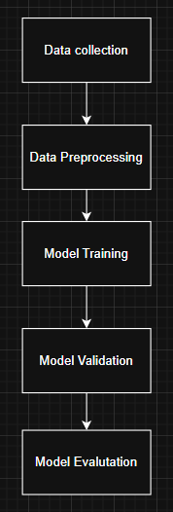

Creating a bread identification system that divides photos into three categories, maltese loaf, baguette and packaged loaf is the main goal of this research. Creating the dataset, which entails collecting and classifying visual data for the three bread categories, is the first step in the solution pipeline’s organized structure. Preprocessing, which includes scaling, normalization, and augmentation to guarantee consistency and model resilience, comes next. The data was then used to train a convolutional neural network (CNN) across ten epochs. The model achieved roughly 99.5% training accuracy and 97.5% validation accuracy during the concurrent validation process, indicating efficient learning with little overfitting.
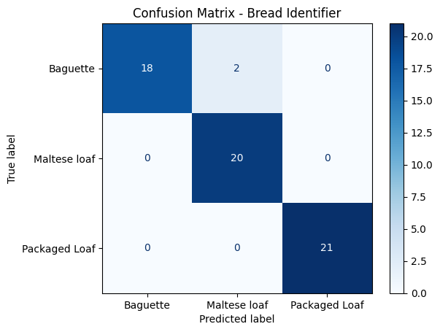 Confusion matrix revealed strong classification performance: 18 out of 20 Baguette images were correctly classified, with only 2 misclassified as Maltese loaf. Maltese loaf was classified perfectly with all 20 samples correctly predicted, and Packaged Loaf also achieved perfect classification with all 21 samples correctly identified. These results confirm the model's high accuracy and its reliability in distinguishing between the three visually similar bread types.

